Simplification

# Bug Zero Charge screenshots

This document presents a screenshot of simplified code that can generate the bugs that are presented for debugging. The test is performed without any user input and all the methods call are automated. As there is no method that can be used to check the charge of the room without changing the code, the print output is taken as a confirmation of the bugs that has been reported.

The automated test done to replicate the bug that lead to the charge for service to be zero when user try to check out is demonstrated in the screenshots below. In figure 1, 2 and 3 the UAT test done to replicate the bug has been automated to show the same bug being generated. The figure 4 automate the generation of bug for 20 times using a loop to generate random variable that is been used as an input and all the test shows that the bug is present.

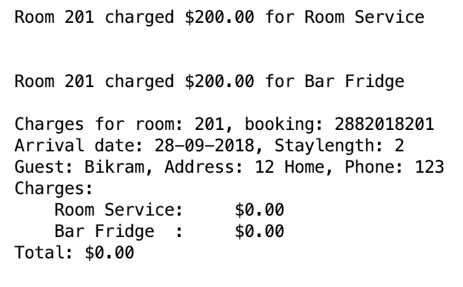

Figure 1 : Bug zero charge case 1.

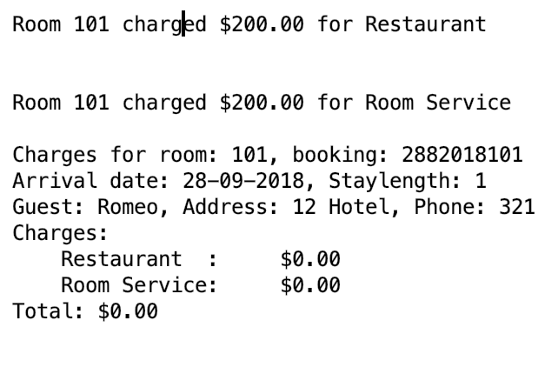

Figure 2 : Bug zero charge case 2.

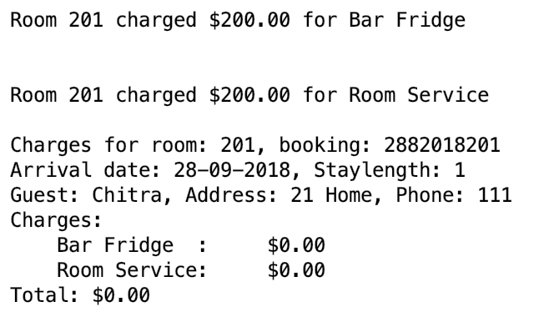

Figure 3 : Bug zero charge case 3.

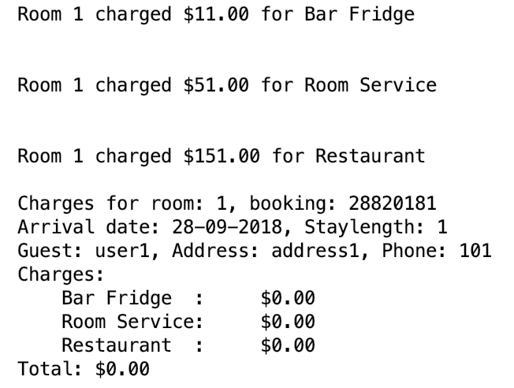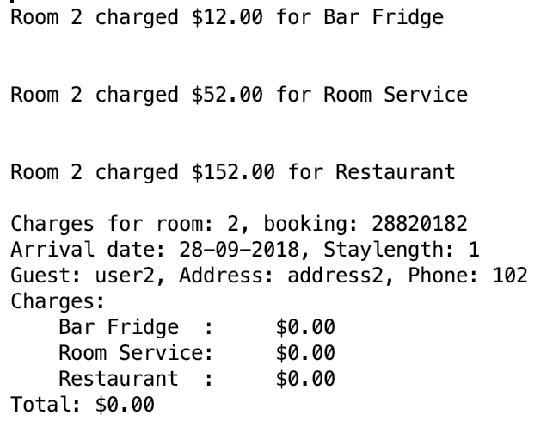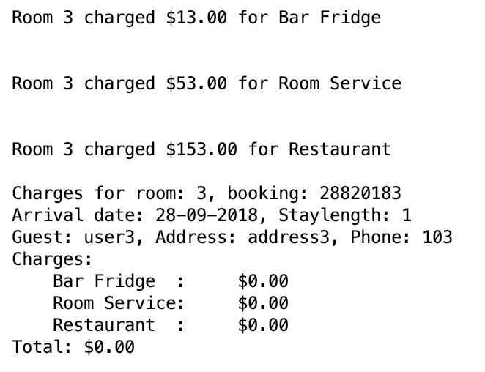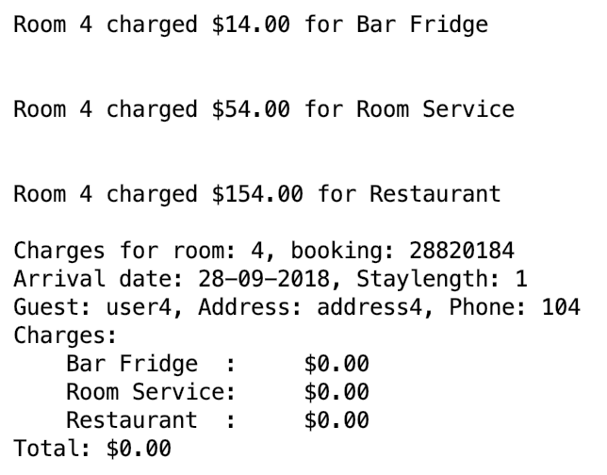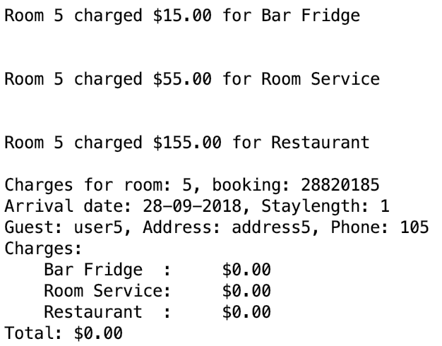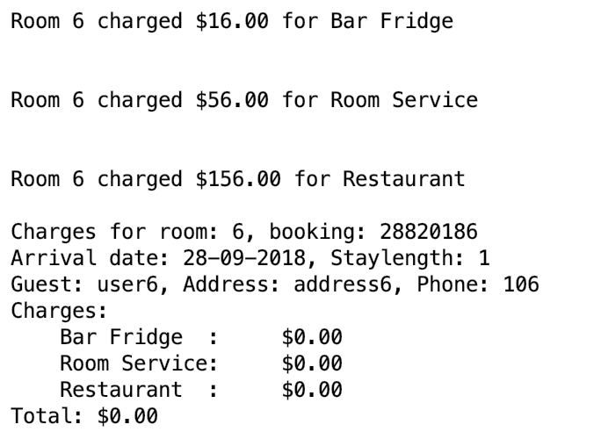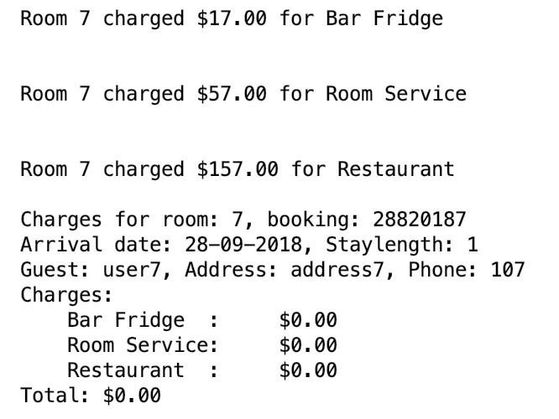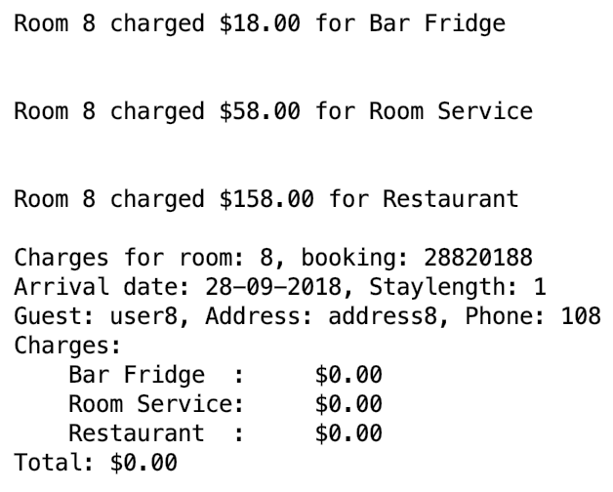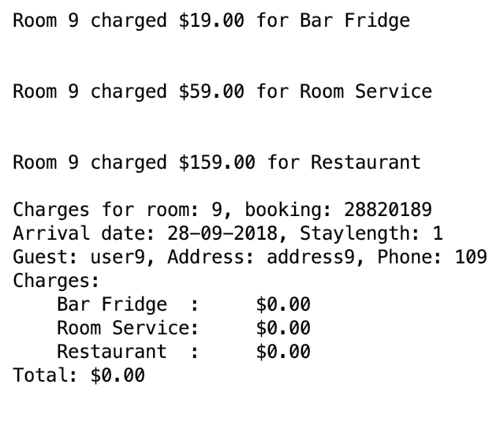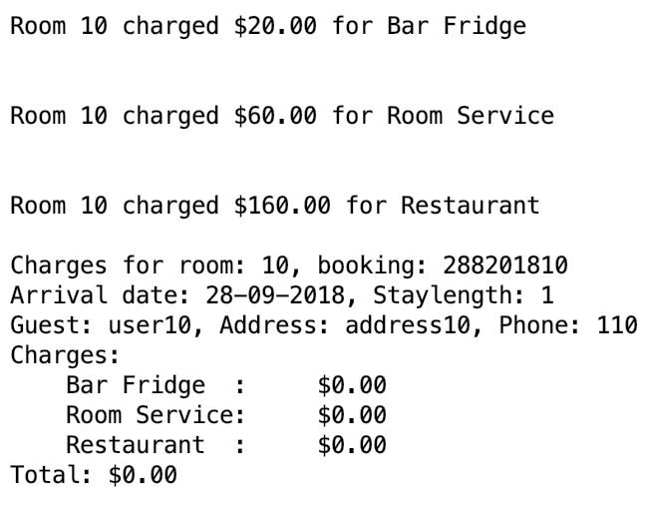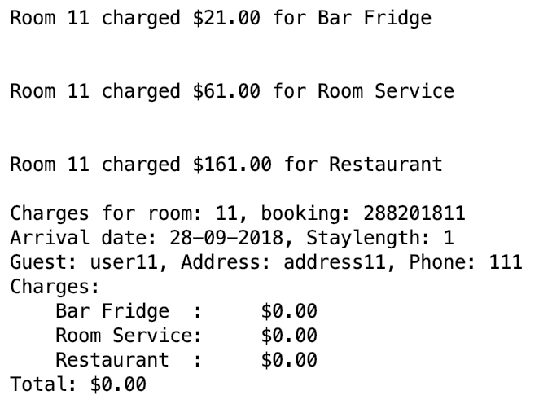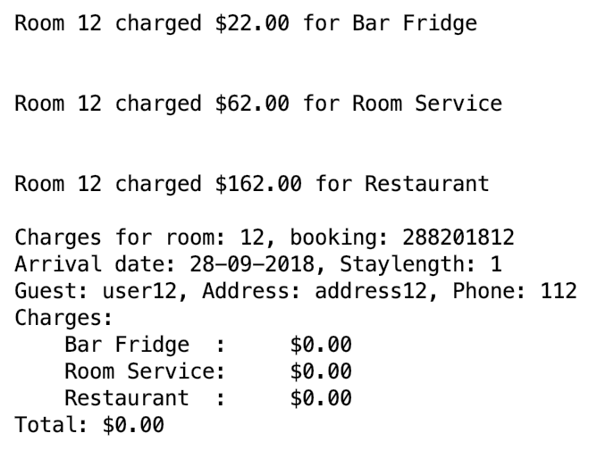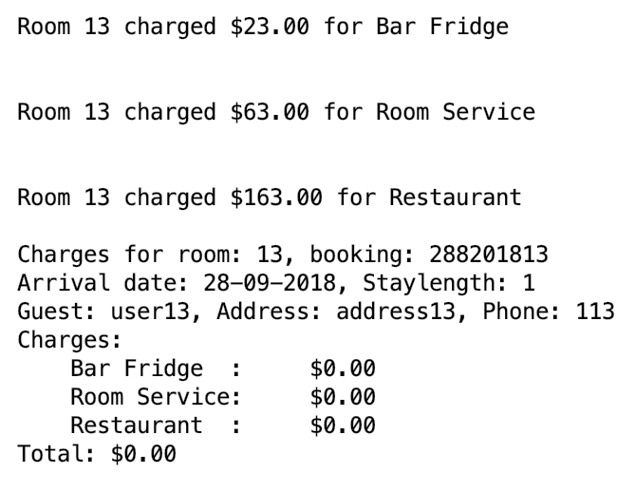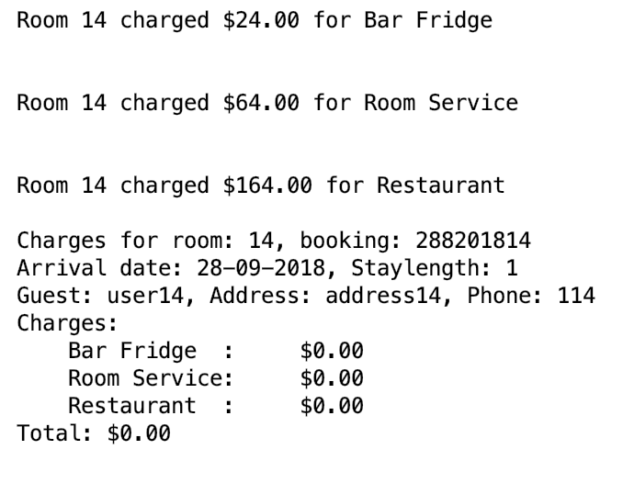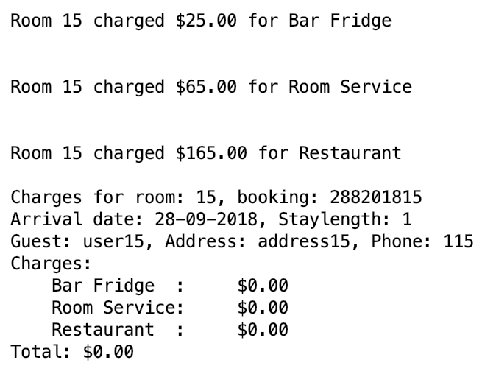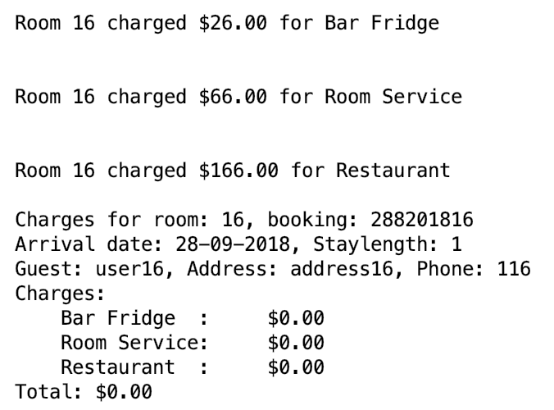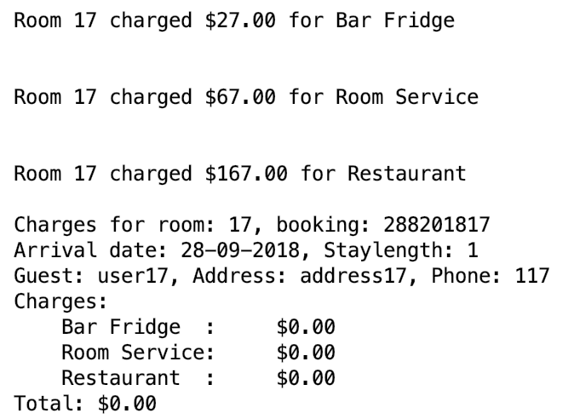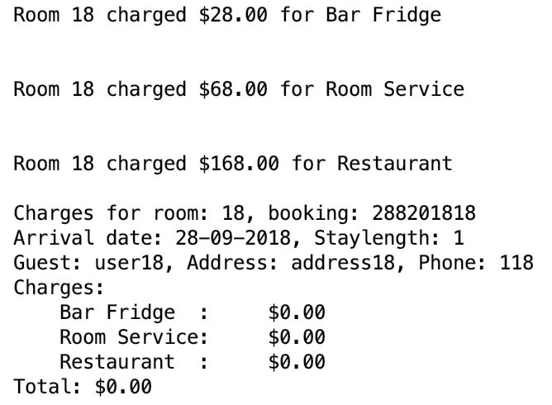

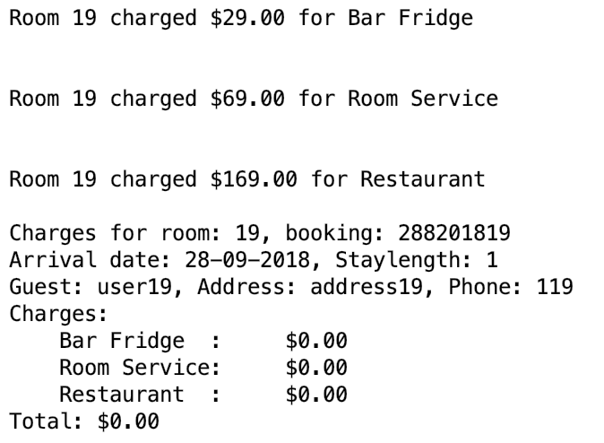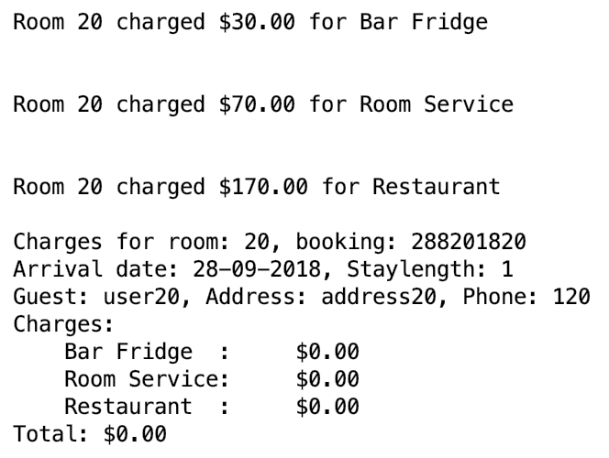

Figure 4: Bug Zero charge case 4

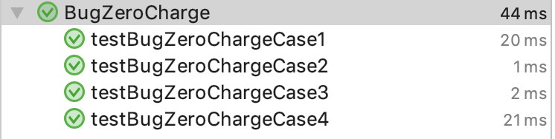

Figure 5: Bug been replicated Successfully.